YunHo(Louis) Law

CS 361

Lab 4 report

DFA Code:

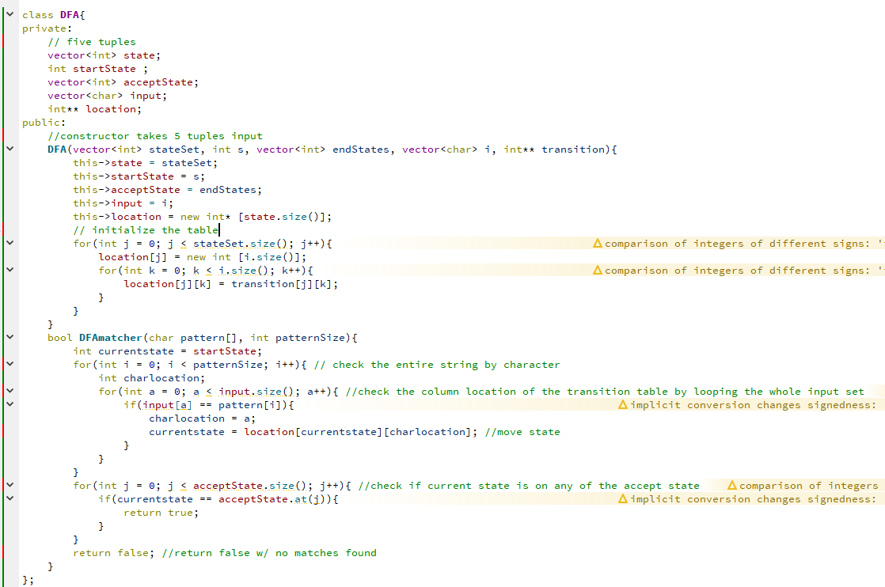

DFA Output: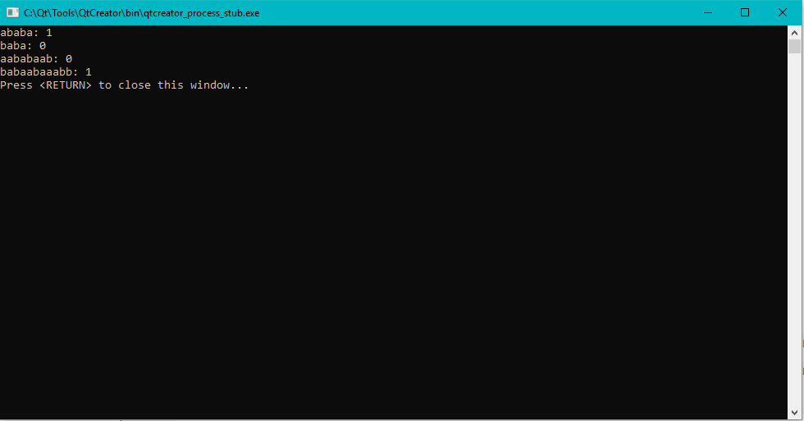

I used the pseudocode from the book as reference to write my DFA class.

I found this algorithm is very difficult to implement in C++ since there the transition table plus the input set, states set, and the accept states set make it really complexed. I assume there are some libraries and function that would help me to optimize the code and make it look way better than this.

Bellman-Ford Code: 